Hello,

Thank you for the opportunity.

I would like to disclose that this is the first time I am using a framework on which I have built this demo.

As this is the first time, I am developing a web application outside of university software and development environments. I decided to use XAMPP as a local development environment to create this demo.

The MVC PHP framework that I chose to work in is CodeIgniter (version 3.1.11). I chose version 3 over the latest version 4 as there were more understandable and coherent tutorials.

Majority of my time was spent learning how to use XAMPP and the CodeIgniter framework as getting the functionality of the demo working was key for this test, after I accomplished this, I styled the demo using CSS.

Due to time restrictions, I made the demo to work on a laptop/desktop, therefore the mobile version may be broken.

I only created 1 view as I thought it would be acceptable for this demo.

**Files**

Model : schoolSearchM

View : schoolSearchV

Controller : schoolSearchC

I have provided the folder of the demo as a zipped file so you can see the code and run the demo.

**Data base design**

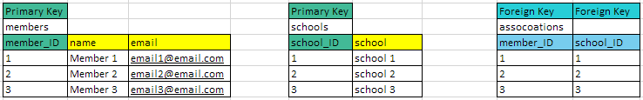**The database structure and data values have been exported to “tct_test.sql” in the tct3 folder.**

**URL**

The URL’s below are what you can use to run the demo on your local environment.

I was unsure on how to host the demo for you to access. Sorry for the inconvenience.

<http://localhost/tct3/index.php/schoolSearchC/saveMemberData>

[http://localhost/tct3/index.php/schoolSearchC/showMemberAssociation](http://localhost/tct3/index.php/schoolSearchC/saveMemberData)